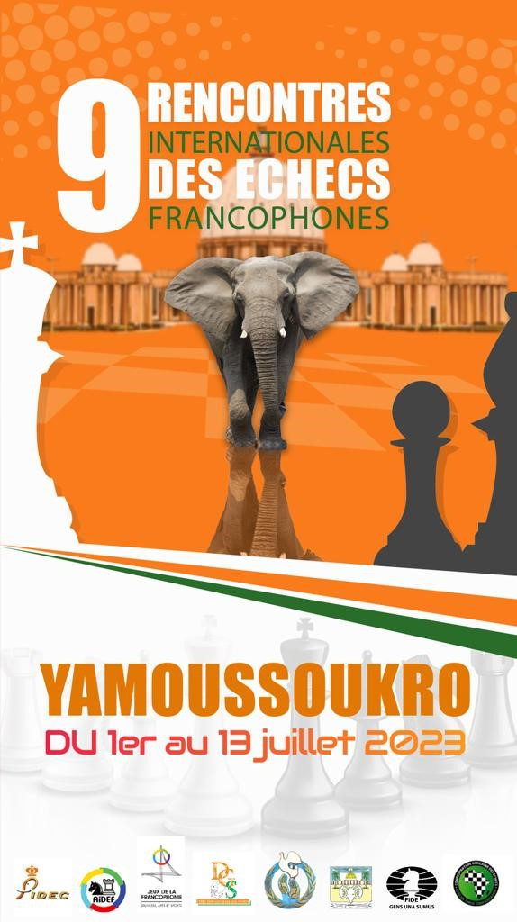

Côte d’Ivoire will host this summer the great annual chess meeting of the world Francophonie at Yamoussoukro

The spirit of conviviality appreciated by the regulars, the warm welcome reserved for the participants, the competitions, the tourist visits, the peripheral activities, the closing ceremonies, the quality of the partner hotel and the exceptional environment of Yamoussoukro will make this tournament an unforgettable event

Francophone individual Championships 2023
Allocation of the following titles for 2022
Francophone Champion
Woman Francophone Champion
Senior Francophone Champion
Veteran Francophone Champion
Rapid games Francophone Champion
Blitz games Francophone Champion

Palmares 2022 – Lyon & Casablanca
Champion: MI Loïc TRAVADON (France)
Woman Champion: WGM Tatiana DORNBUSCH (Monaco)
Senior Champion: MI Fred BEREND (Luxembourg)
Veteran Champion: Skalli TAOUFIK (Maroc)
Blitz games Champion: MI Loïc TRAVADON (France)
Rapid games Champion: GMI Maxime LAGARDE (France)

Yamoussoukro
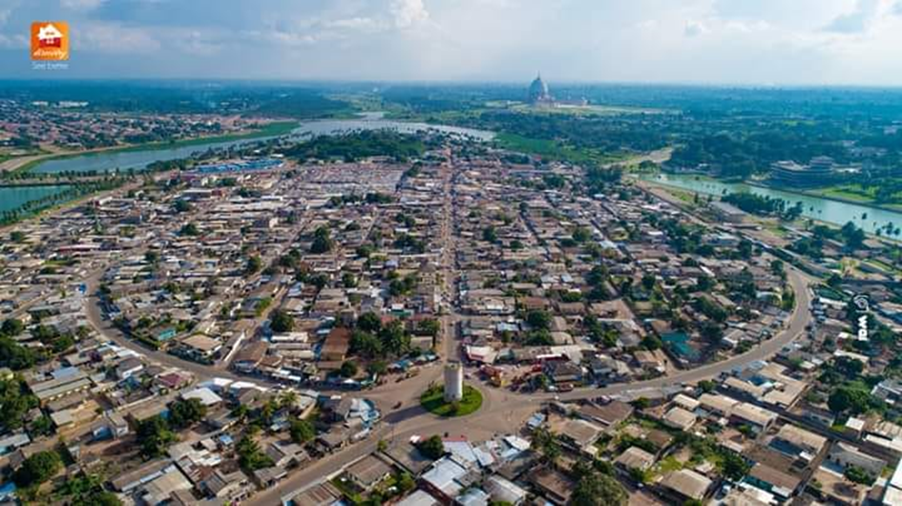
https://www.youtube.com/watch?v=ssqyr8057qQ

Yamoussoukro is the 5th most populated city in Côte d'Ivoire after Abidjan, Bouake, Daloa and Korhogo. It is located 240 km from Abidjan in the center of Côte d'Ivoire in the Baoulé country commonly known as the Great Lakes region.

Home of former president Félix Houphouët-Boigny (1905-1993), Yamoussoukro has been officially the capital of Côte d'Ivoire since March 21, 1983. It owes everything to the latter who made it his fief. He liked to say it; «Abidjan was built by the colonizer, and I built Yamoussoukro». It is a modern city that differs from Abidjan the ex-Capital, by an original architecture.

The city has also become famous since the consecration of the Basilica of Our Lady of Peace by Pope John Paul II in 1990. With its stained-glass windows and dome overlooking the building, it is the largest in the world. It was built in three years and is visible from the four cardinal points of the city.

Yamoussoukro draws its singularity also by the fact that it is a university city. Four major universities, once autonomous, now form the Houphouët Boigny National Polytechnic Institute, which forms a national elite.

It is also distinguished by the many artificial lakes that communicate with each other and that give a certain allure to the city. These lakes, especially those adjacent to the Presidential Palace, are populated by caimans. Theys are called the Cayman Lake.

The city has 350,000 inhabitants. The dominant ethnic group is the Baoulé of the large Akan group from neighboring Ghana. The Akan are mainly located in the Grand Centre of Côte d'Ivoire.

Another special feature of Yamoussoukro is the road. Indeed, all the city’s roads are very wide. No other city in Côte d'Ivoire has such road infrastructure.

A magnificent football stadium fully covered and compliant with FIFA standards is preparing to host matches of the African Cup of Nations in Côte d'Ivoire in early 2024.

A stone’s throw from Yamoussoukro is the Abokouamékro Animal Park, which is a reserve called «the Treasury of Ivory Coast» and weavers in the village of Bomizambo who make beautiful Baoulé loincloths.

In Yamoussoukro, the traditional language is Baoulé, the official language French, but the vehicular language understood by most of the population is Dioula.

Yamoussoukro is one of the cultural and tourist cities of Côte d'Ivoire with multiple tourist assets.

Organized visits to Yamoussoukro and surroundings

The Basilica of Our Lady of Peace

It is simply the largest Christian-style religious building in the world. It is the largest religious tourist attraction in the region. People go there for a number of reasons. When some go there for spiritual reasons, others run there to admire its extraordinary architecture. Do not miss anything in the world to discover this monumental construction.

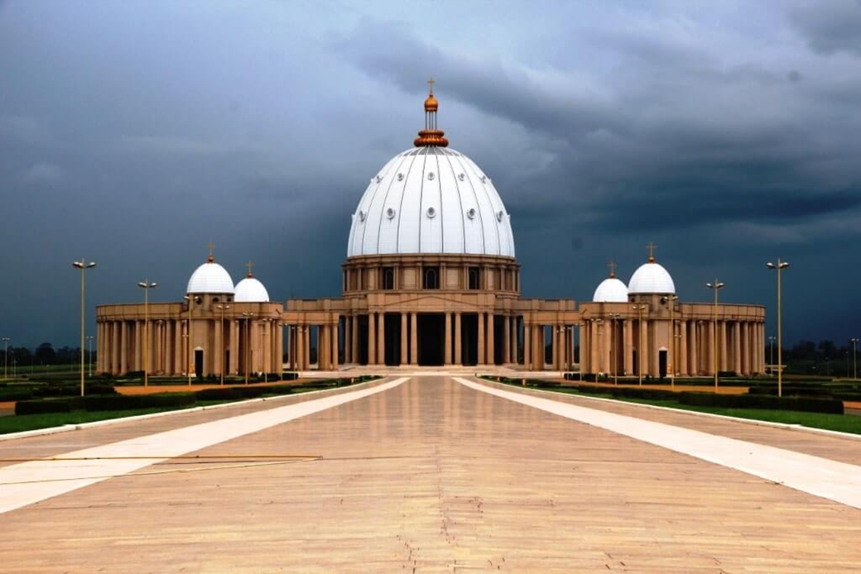

https://basiliquenotredamedelapaix.com

Abokouamékro National Animal Park

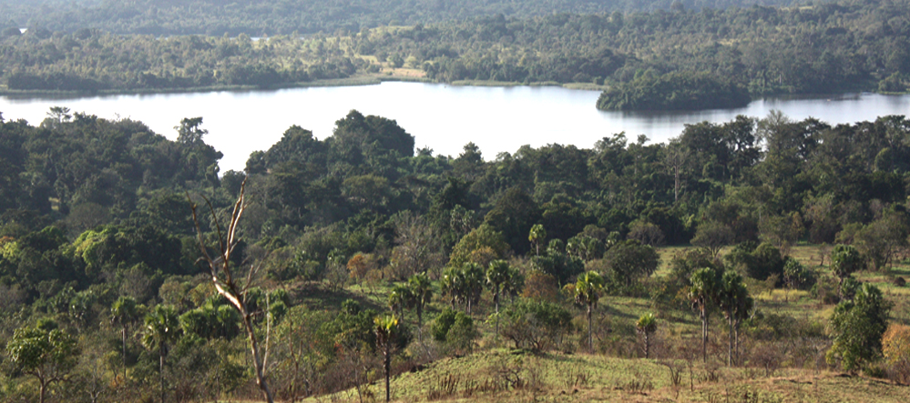
Created in 1986 at the initiative of the late President Félix Houphouët-Boigny for the development of tourism, the Abokouamékro wildlife park covers an area of 20430 hectares including 7230 equipped for tourist visits. The reserve is home to rhinos, buffalo, bubales, antelopes, buffalo cobes and many other animal species. The Abokouamékro Wildlife Reserve is one of the essential links in the region’s tourism development.
https://rezoivoire.net/ivoire/ressources/151/le-parc-animalier-dabokouamekro.html

The weavers of Bomizambo

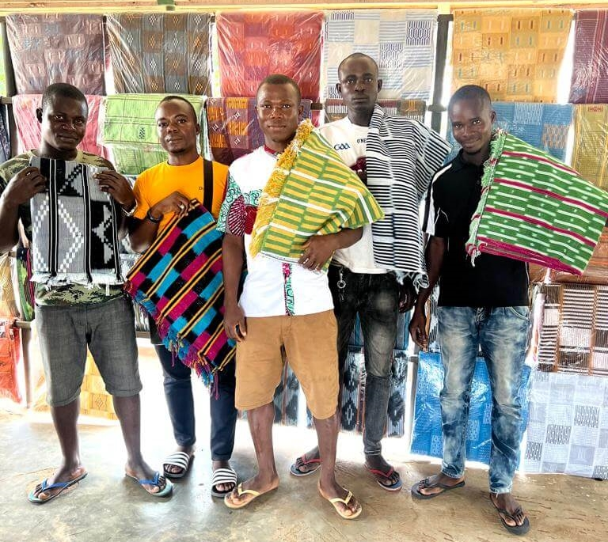
Baoulé loincloth is a handwoven fabric made by the Baoulé people in Bomizambo and its surroundings in Ivory Coast according to an ancestral technique. Only men and children can be weavers, and this know-how is perpetuated from father to son.
https://levoyageducalao.com/cote-divoire/bomizambo-la-cite-du-pagne-baoule/
The Félix Houphouët-Boigny Foundation for the Search for Peace

https://www.youtube.com/watch?v=hKjiMo5OcsM
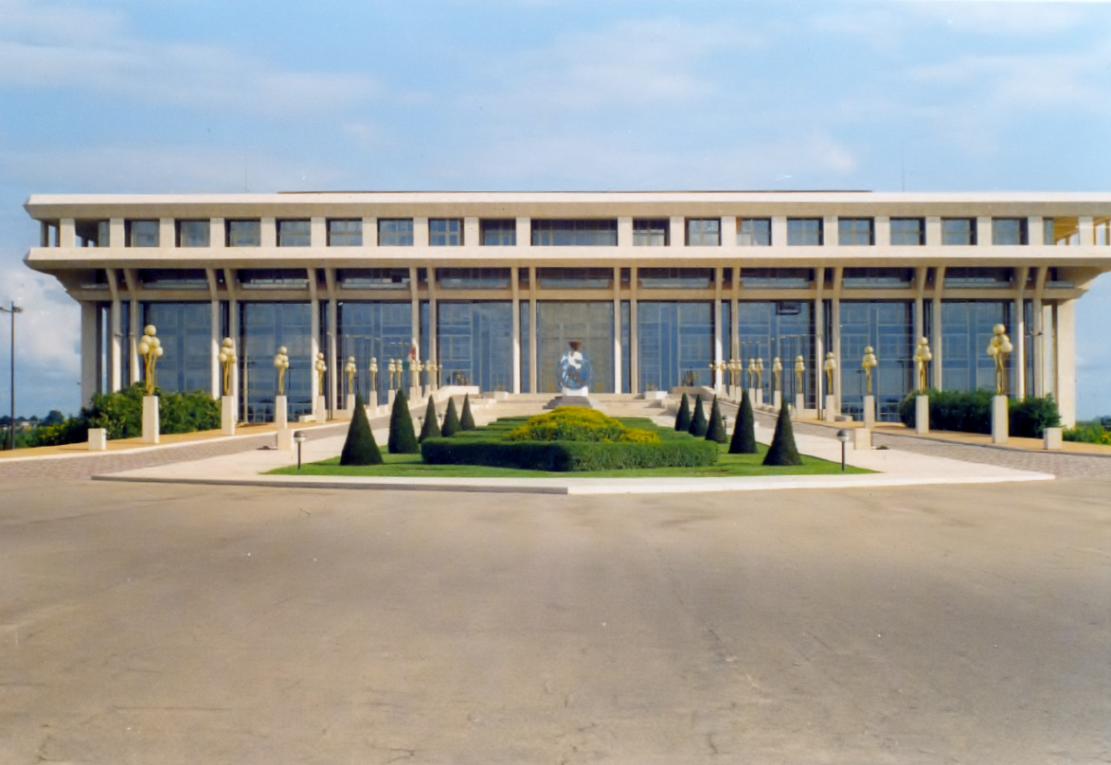
Founded in 1973 as the Félix Houphouët-Boigny Foundation, in 1997 it became the Félix Houphouët-Boigny Foundation for the Search for Peace. It was at the origin of the International Congress on Peace in the Minds of Men in 1989 and the Yamoussoukro Declaration for Peace in 1997, both of which were placed and organized under the aegis of UNESCO.

The crocodile lake

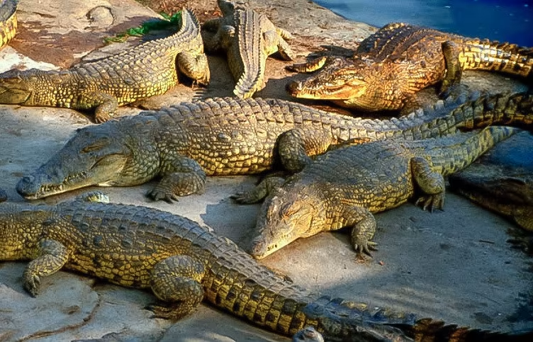

Yamoussoukro crocodiles populate the lake surrounding the Presidential Palace. These are Nile crocodiles. These animals weigh nearly a tonne each and are up to six metres long. They can jump several metres to grab the food they are given daily. The lake and its crocodiles are a renowned tourist attraction throughout West Africa. They are also and above all associated with the political power of Félix Houphouët-Boigny and their prestige contributes to African symbolism.
The Kossou Dam

https://www.youtube.com/watch?v=wEQgBdtDpYI
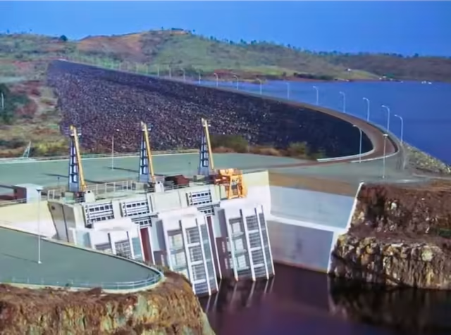

The Kossou dam, built in 1970 on the Bandama Blanc, is the largest hydraulic dam in Côte d'Ivoire and its first major hydraulic structure.

Félix Houphouët-Boigny National Polytechnic Institute

The Institut national polytechnique Félix Houphouët-Boigny (INP-HB) was created by decree in 1996, amalgamating and restructuring four prestigious schools: the École nationale supérieure d'agronomie (ENSA), the École nationale supérieure des travaux publics (ENSTP), the Institut agricole de Bouaké (IAB) and the Institut national supérieur de l'enseignement technique (INSET). Called the «Grandes Écoles de Yamoussoukro», they are the flagship, with the Félix Houphouët-Boigny University
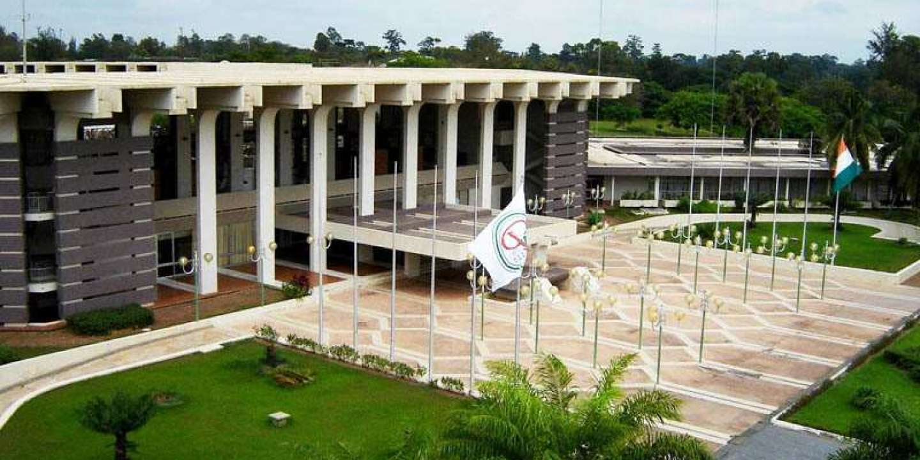
of Abidjan, university life and training in the country.

Accommodation and Playing Hall

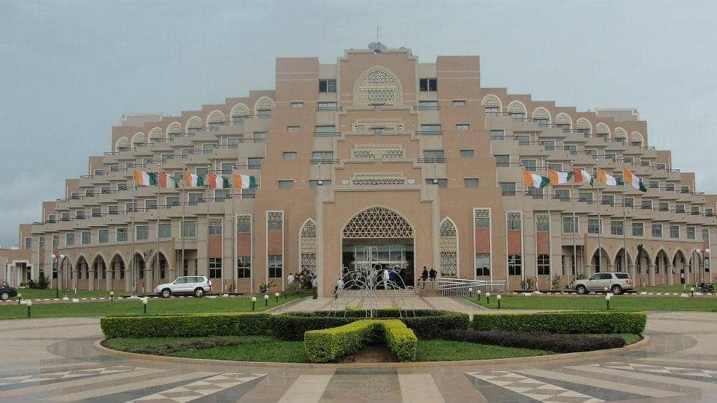
HP RESORT (HOTEL DES PARLEMENTAIRES) 4*
https://hp-resort.ci/?p=espaces#salles

Nestled in the heart of Yamoussoukro, the Hotel des Parlementaires is a 4-star architectural gem to discover and make discover. Built in an area of 8 hectares, the Hotel des Parlementaires has a capacity of 300 rooms including 12 suites.

2 Restaurants, 1 Fitness center, Wifi access, Bathrobes, 2 Bars, 1 Night club, Elevators, Mini bar, 1 Fire station, 1 Barbecue area called «THE GRILL», Several conference rooms and workshop, Parking nearby, Access 24h/24h, 1 Concierge, Safe-deposit boxstrong in room, VISA/MASTER credit cards accepted, 1 Pressing, cable TV, Air conditioning, 1 Swimming pool.
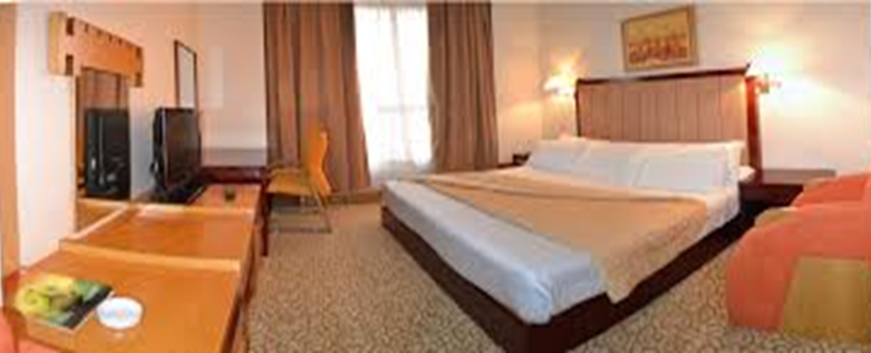

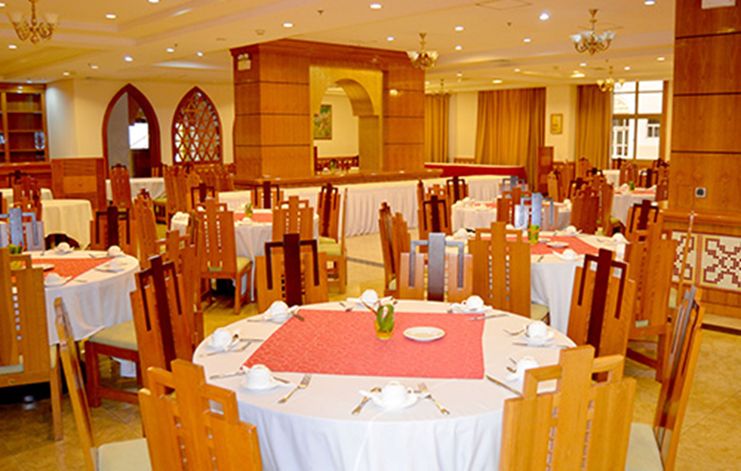
Breakfast, lunch and buffet dinner will be served at the Parliament Restaurant
Capacity of 250 places - Other meals are also provided outside.

Rates accommodation per night per person

Double room 30€ - Single room: 50€ breakfast included.

Catering service for lunch and dinner: €15 per meal.

Transfers will be provided free of charge to and from Abidjan Airport.

Official Ceremonies

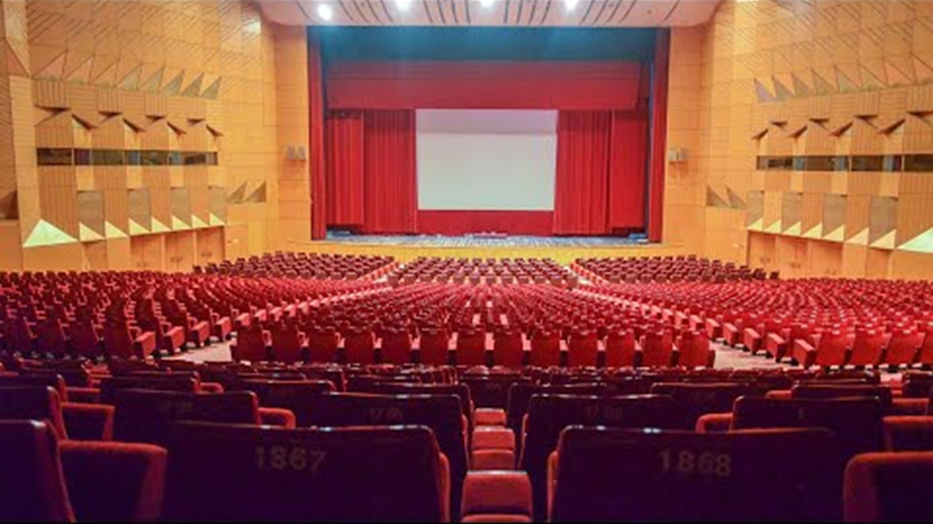
The opening ceremony as well as the closing ceremony including the award ceremony will take place in the amphitheatre of the Felix Houphouët Boigny Foundation for the Search for Peace.
Competitions

- Classical game Championship

Open 9-round tournament - Swiss accelerated system Baku: 1 virtual point for the first 3 rounds and 1/2 virtual point for the 4 and 5 rounds.

FIDE rated / 90 min + 30 sec per move.

Players have the right to request 2 Bye (1/2 point) in the first 6 rounds provided they inform the referee before the match.

A separate classification will be established for the titles of Woman Champion, Senior Champion +50 and Veteran Champion +65

Registration fee: 30€ - IM and GM free.

- Rapid game Championship

Open 9-round tournament Swiss System.

FIDE rated / 15 min + 10 sec per move.

Registration fee: 15€ - IM and GM free.

- Blitz game Championship

Open 11-round tournament Swiss System

FIDE rated / 5 min + 3 sec per move.

Registration fee: 10€ - IM and GM free.

The first 40 chess boards will be broadcast live on the internet.

The prizes are indivisible, not cumulative and assigned instead to the general classification.

Split: 1. Direct confrontation – 2. Truncated Buchholz – 3. Buchholz - 4. Elo performance

Swiss Program – Manager

International Arbiter Laurent Freyd (France) has been appointed as chief arbiter.
_______________________________________________________________________________________________

According to their FIDE ID, only players from Francophone Chess Association (AIDEF) member countries are allowed to participate in the Francophone Championships

https://aidef.fide.com/spip.php?article27

Guaranteed prizes: 17000 € + trophies
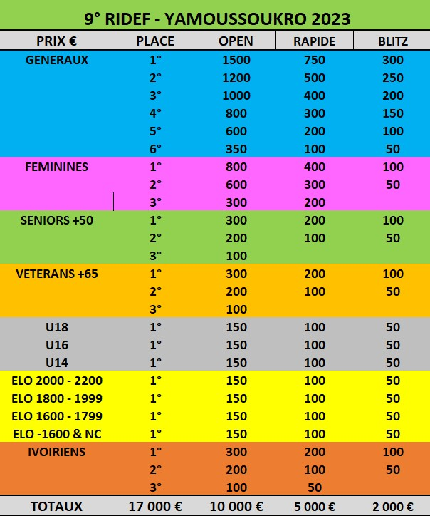

Schedule
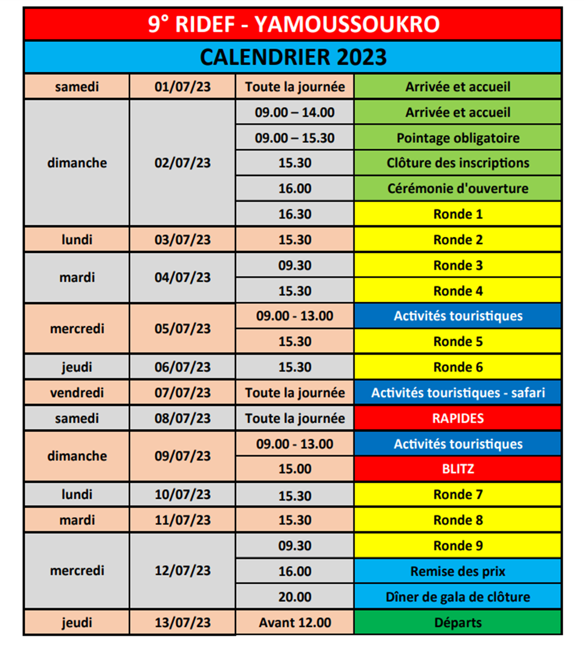

RIDEF 2023 Website

http://www.9ridef.net (from 1st April)

Registration - Information – Reservations

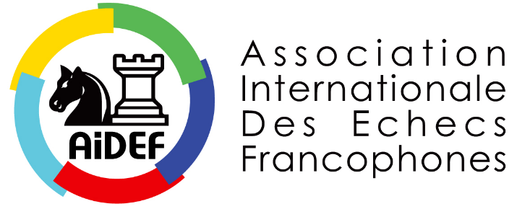

Patrick VAN HOOLANDT

Tournament director
President of AIDEF

+33 624 97 11 24 vanhoolandt@aol.com a.i.d.e.f@aol.fr

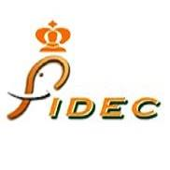

Fédération Ivoirienne des Echecs

Justin BROU
justin_brou6@yahoo.fr
President of FIDEC
Tournament organizer +225 0707956024

Laurent FREYD laurent.freyd@gmail.com

Chief Arbiter of the tournament +33 622 31 76 10

