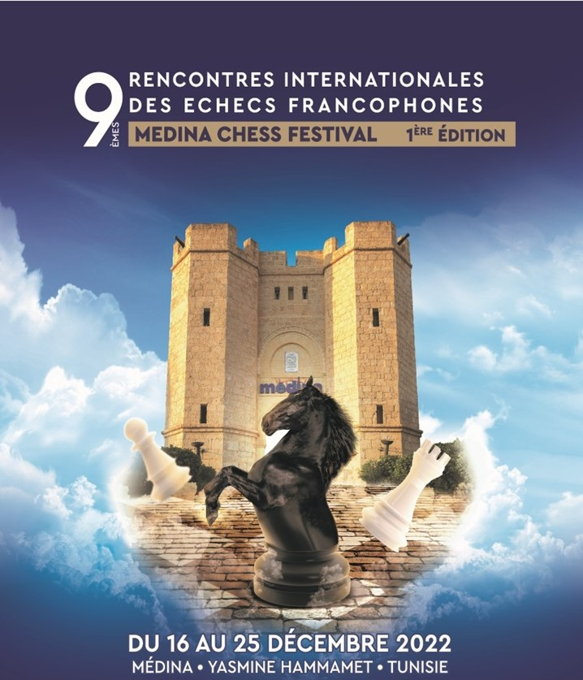
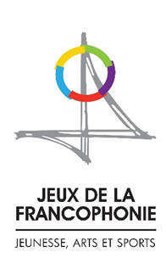
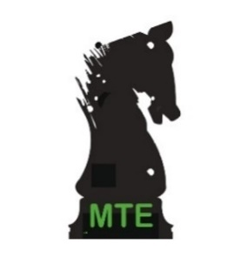
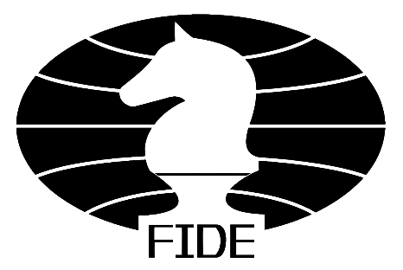
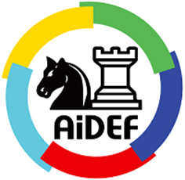
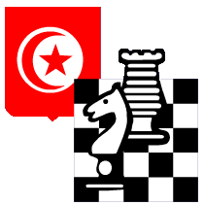

Tunisia will host at the end of this year the great annual chess meeting of the world Francophonie at Yasmine Hammamet

The spirit of conviviality appreciated by the regulars, the warm welcome reserved for the participants, the competitions, the excursions, the peripheral activities, the splendid playing hall of the Medina Mediterranea, the closing ceremonies, the quality of the partner hotels and the exceptional environment of Yasmine Hammamet will make this tournament an unforgettable event.

Francophone individual Championships 2022
Allocation of the following titles for 2022

Francophone Champion
Woman Francophone Champion
Senior Francophone Champion
Veteran Francophone Champion
Blitz Francophone Champion

Winners of the previous edition in 2022 in Casablanca (2021 titles)

Champion : MI Loïc TRAVADON (France)
Woman Champion : WGM Tatiana DORNBUSCH (Monaco)
Senior Champion : MI Fred BEREND (Luxembourg)
Veteran Champion : Skalli TAOUFIK (Maroc)
Blitz Champion : MI Loïc TRAVADON (France)

Yasmine Hammamet
www.youtube.com/watch?v=5DNTknRGhC4
The new district of Yasmine, located about ten kilometers south of Hammamet, is a seaside resort and has many advantages to seduce holidaymakers.

This area planned to give a new breath to Tunisian tourism offers within a few kilometers luxury hotels, a marina hosting sailing boats - replicas of old merchant ships used for the organization of excursions at sea -, cafes and restaurants along the beach, supermarkets, a skating rink - surprising but appreciated -, as well as the famous modern complex of the "Medina Mediterranea" - superb reconstruction of a traditional Arab city that shelters behind its Souk ramparts, restaurants, the Diar Lemdina Hotel, a congress center and the Carthage Land theme park.

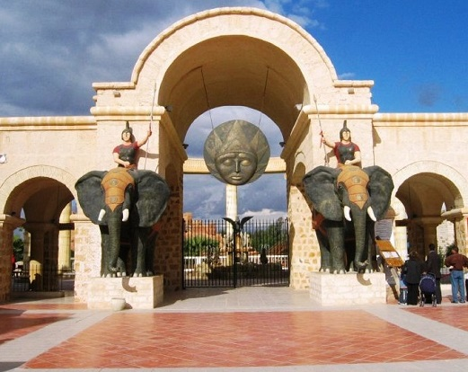

The Medina Mediterannea of Yasmine Hammamet host the largest amusement park in North Africa Imagined on the theme of the ancient Carthage.

“Carthage Land” offers
various and varied attractions and entertainment for young and old on a plot of five hectares.

https://www.medina.com.tn/en
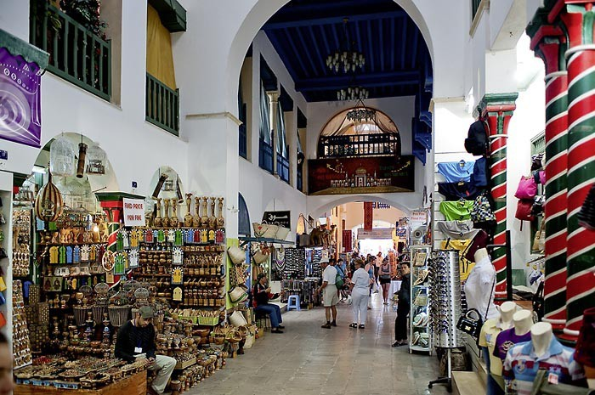

Playing hall: Medina Conference & Expo Center
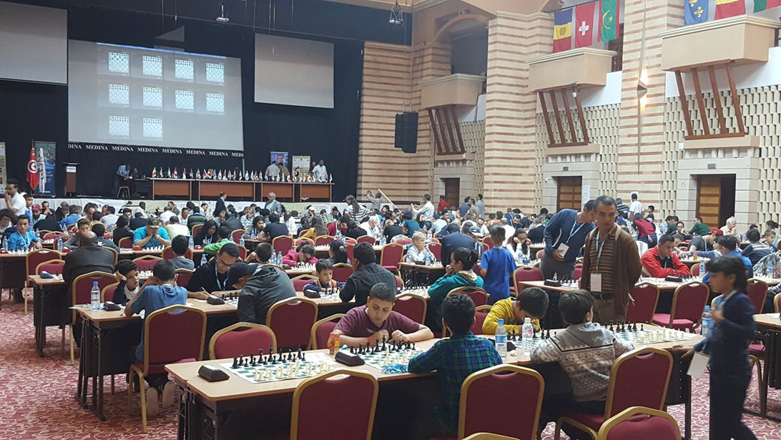
The Medina Congress Centre offers a full range of rooms with modern equipment, making it the ideal place to host the playing area, analysis and arbiter’s rooms, ancillary activities and the closing ceremony.
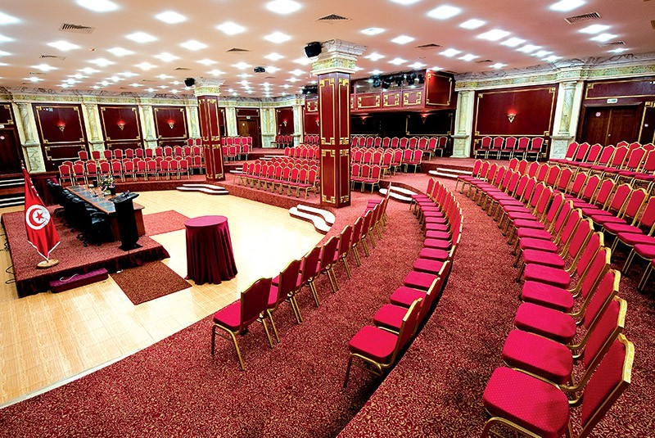
A multipurpose plenary room Hannibal (2200 people), a Caesar amphitheater (600 people), an Odyssey amphitheater (350 people), 25 sub-committee rooms (between 50 and 250 people)
https://www.medina.com.tn/en/congress-exhibition-center

Accommodation

Hotel Diar Lemdina 4*

As part of the «Medina Mediterranea» complex, this hotel offers you the assurance of a high standard accommodation in one of its 250 suites and rooms distributed in its three sumptuous residences

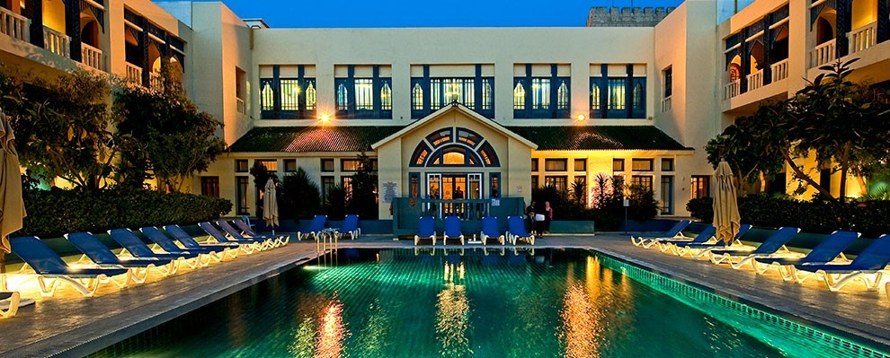

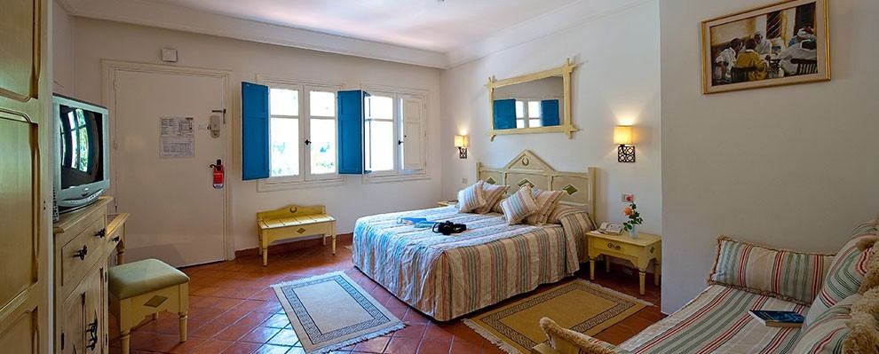
https://diarlemdina.medinahotelsandresorts.com/en

Hotel Bélisaire & Thalasso 4*
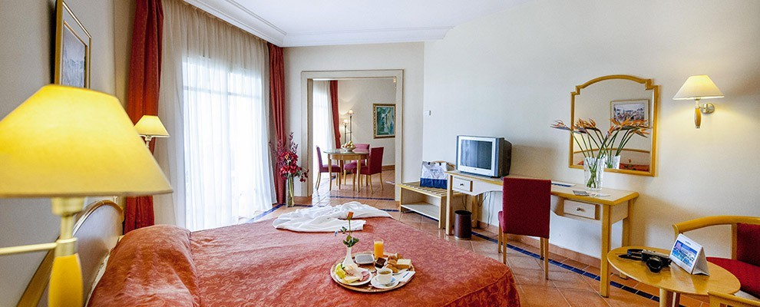
Just 700 meters from the «Medina Mediterranea» complex, the tournament venue, this hotel is ideal for family holidays. Free shuttles will be made available to participants. It has 276 double or single rooms including 4 equipped for disabled.
These rooms are spacious, decorated with refinement and overlooking the pool or garden. You will certainly be seduced by its vast gardens and its magnificent thalassotherapy center. In addition, you can easily and directly access its private beach just 200m from the hotel.
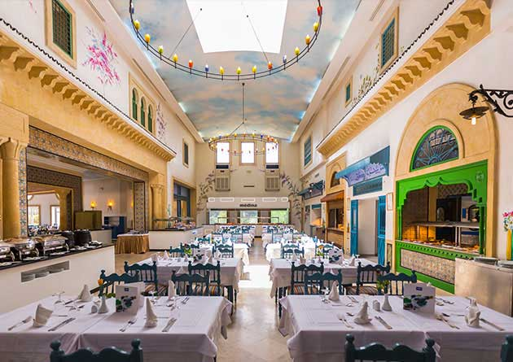

True to its reputation, the Bélisaire & Thalasso 4* hotel offers a rich and varied gastronomic program, day, and night. You can taste the true Tunisian and Mediterranean gastronomy in one of the restaurants of the hotel «Zeintouna» or «O blu»

https://belisaire.medinahotelsandresorts.com/en

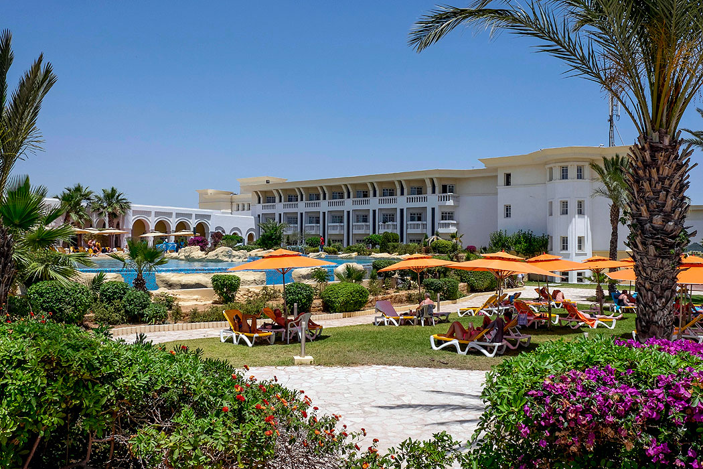

Full board rates (per night per person)
(Single room supplement = 15€)

- Hotel Diar Lemdina 4* : 65 €
Senior Suite: each suite consists of a bedroom and a living room.
Triple/Quadruple Ambassador Suite: Each suite consists of two separate bedrooms, two bathrooms and a living room.

- Hotel Bélisaire & Thalasso 4* : 75 €
Double room

These negotiated prizes for tournament participants include:

- A water bottle and a snack for each game

- A sightseeing tour

- Hot water bathing at Korbous or Hammam Spa where Hot Sodium Chlorinated Waters and Cold Calcium Sulphide Waters treat rheumatism, arthritis, and nervous system conditions

- 15% discount on Spa and Hammams packages at the Medina Spa Centre

- Christmas Gala Dinner

Tourist Activities

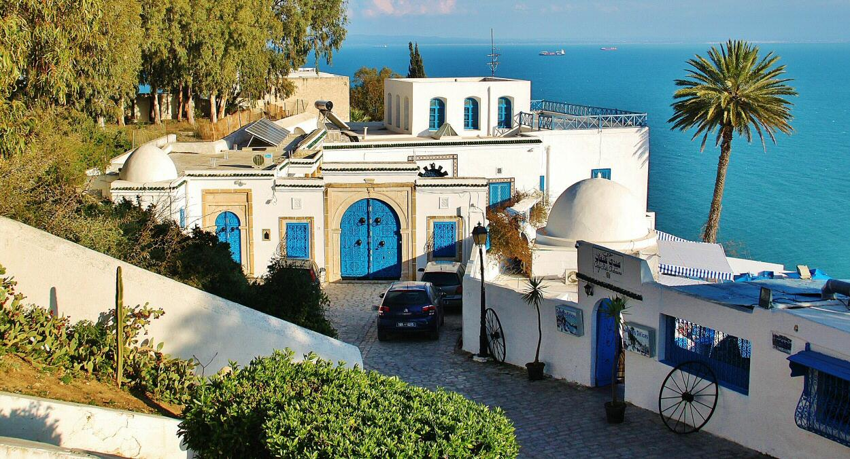
Excursion 1 - Sidi Bou Saïd & Carthage circuit
Sidi Bou Saïd, the balcony of the Mediterranean:

https://guide-voyage-tunisie.com/en/sidi-bou-said-town

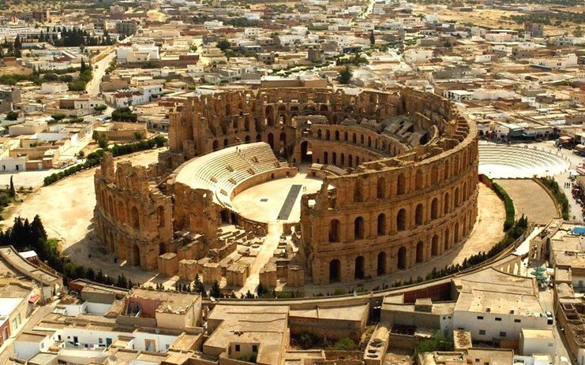

Carthage, the famous ancient city:
https://guide-voyage-tunisie.com/en/carthage-archaeological-site

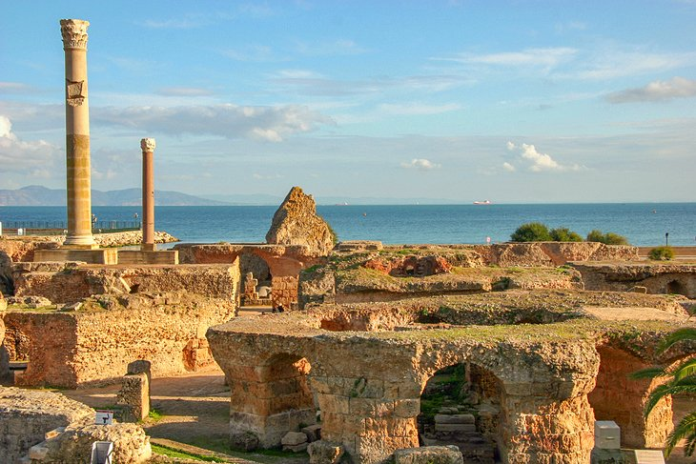
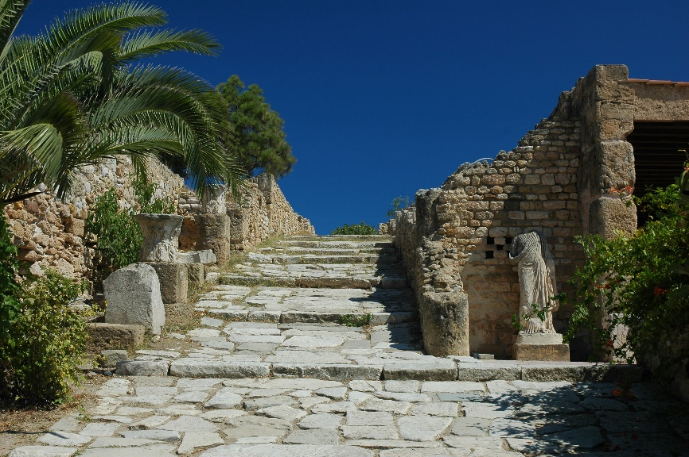

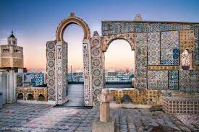
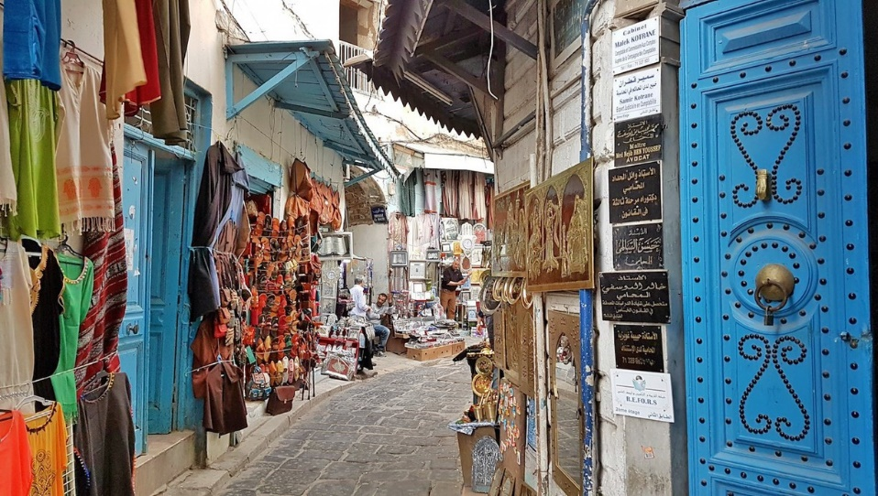
Excursion 2 – Medina of Tunis & Bardo museum
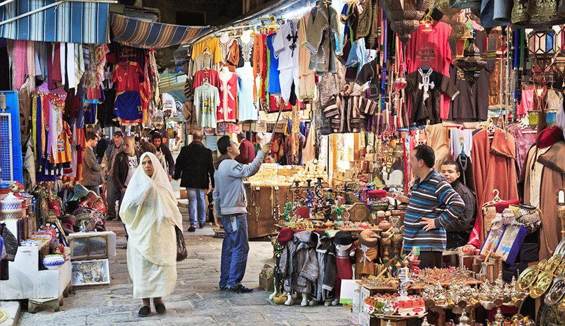

The medina of Tunis, the historic heart of the city, is a UNESCO World Heritage Site

https://guide-voyage-tunisie.com/en/the-medina-of-tunis

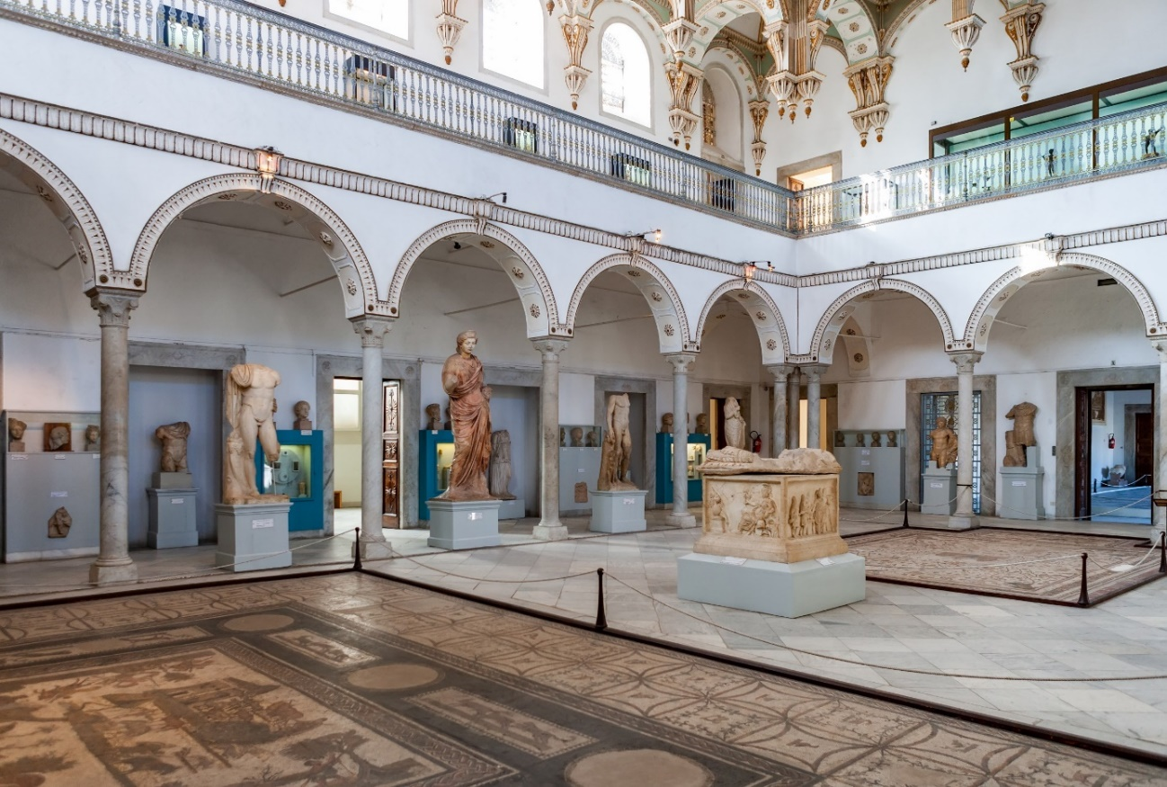

Bardo National Museum gathers one of the most beautiful collections of Roman mosaics in the world

https://en.wikipedia.org/wiki/Bardo_National_Museum_(Tunis)

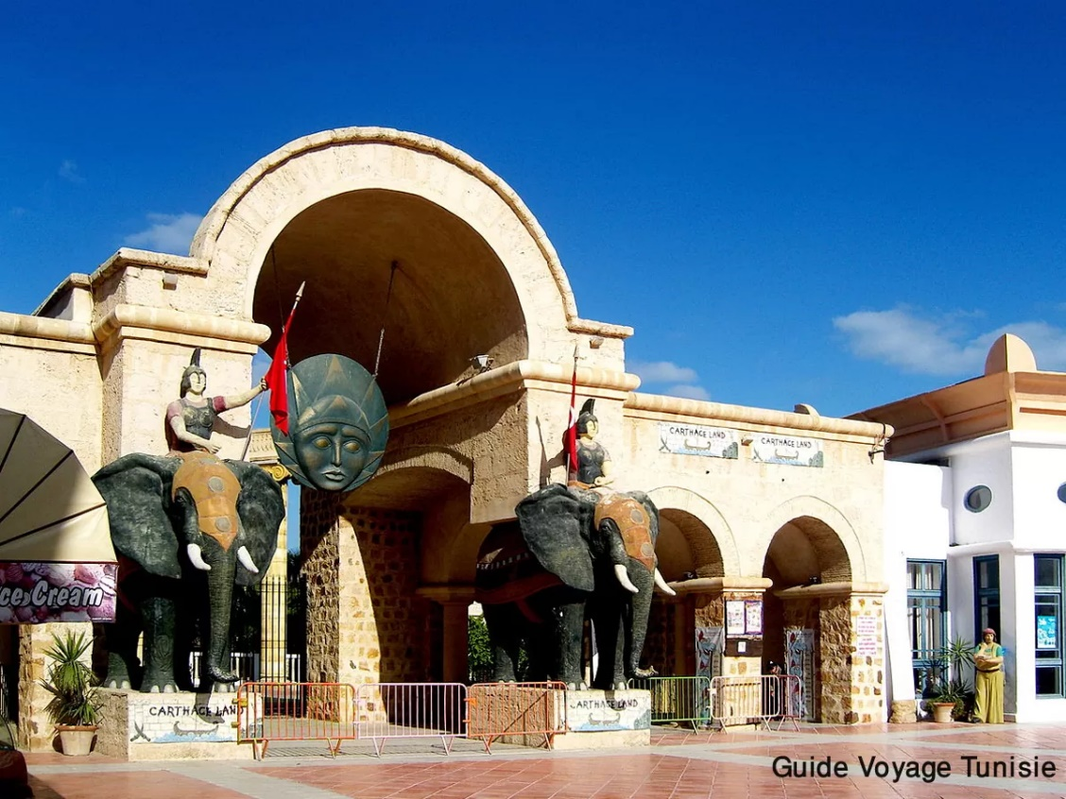

Le parc d’attractions “Carthage-Land”

https://guide-voyage-tunisie.com/en/carthage-land-in-hammamet

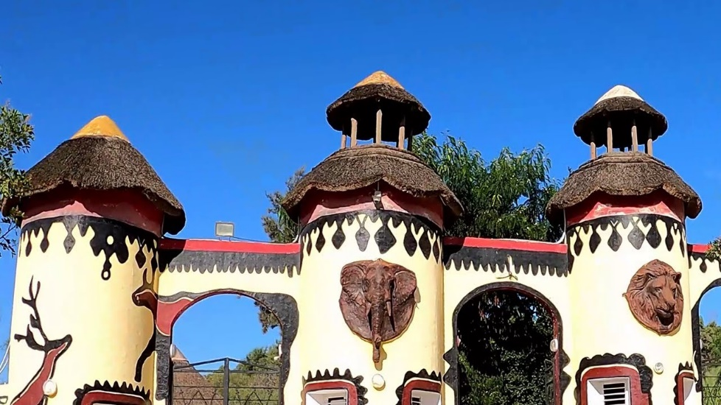

The Friguia Parc zoo

www.youtube.com/watch?v=Le2r4IklUd8

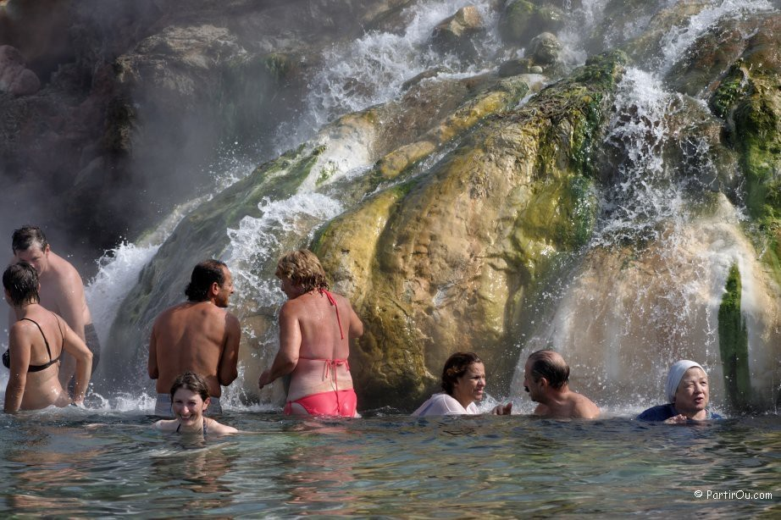

The hot springs of Korbous

https://www.youtube.com/watch?v=jgGfV5PO78Q

Competitions

According to their FIDE ID, only players from Francophone Chess Association (AIDEF) member countries are allowed to participate in the Francophone Championships
https://aidef.fide.com/spip.php?article27

- Classical game Championship
Chess-results: https://chess-results.com/tnr678777.aspx?lan=1&art=0&turdet=YES

Open 9-round tournament - Swiss accelerated system Baku: 1 virtual point for the first 3 rounds and 1/2 virtual point for the 4 and 5 rounds.

FIDE rated / 90 min + 30 sec per move.

Players have the right to request 2 Bye (1/2 point) in the first 6 rounds provided they inform the referee before the match.

Registration fee: 30€ - IM and IGM free.

- Blitz Championship
Chess-results: https://chess-results.com/tnr678778.aspx?lan=1&art=0&turdet=YES
Open 11-round tournament – Swiss system
FIDE rated / 5 min + 3 sec per move.
Registration fee: 15€ - IM et IGM free.

----------------------------------------------------------------------------------------------------------------------

A separate classification will be established for the titles of Woman Champion, Senior Champion+50 and Veteran Champion+65

The first 10 chess boards will be broadcast live on the internet.

The prizes are indivisible, not cumulative and assigned instead to the general classification.

Split: 1. Direct confrontation – 2. Truncated Buchholz – 3. Buchholz - 4. Elo performance

Swiss Program – Manager

International Arbiter Laurent Freyd (France) has been appointed as chief arbiter

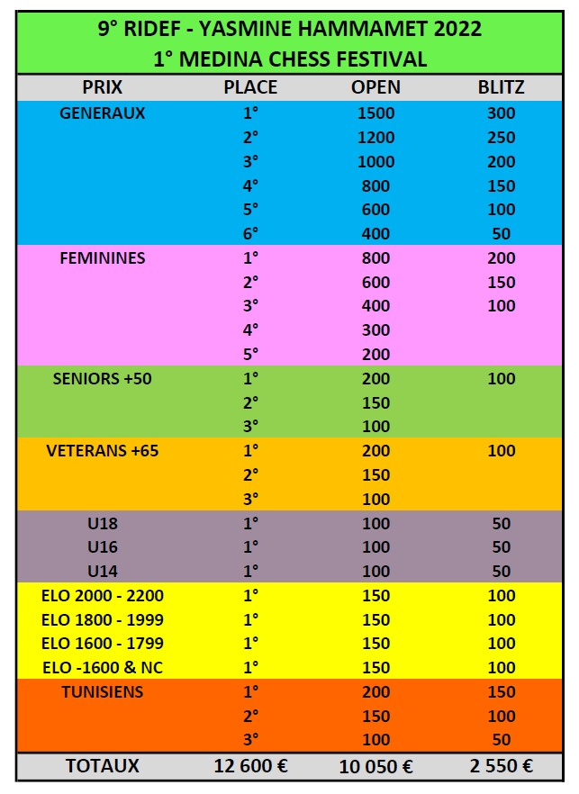
Guaranteed prizes: 12600 € + special prizes - trophies

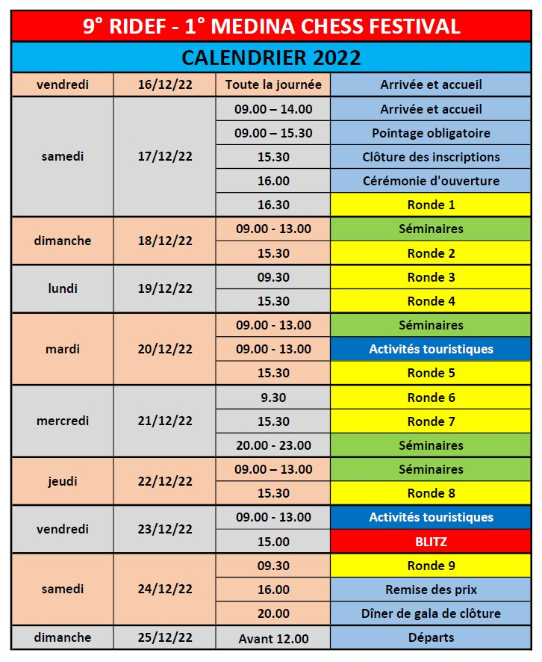

Information : RIDEF 2022 website:

http://ridef2022.com (available from October 1)

Registration and information :

La Maison Tunisienne des Échecs – MTE

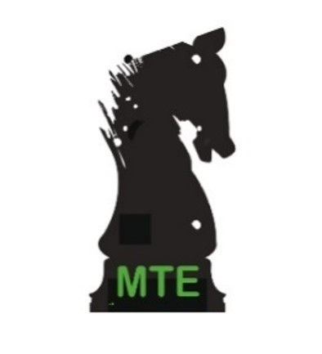
Mohamed ZOUAOUI

Tournament director
Vice-president of AIDEF

+216 23 360 840

mohamed.zouaoui@bmail.tn

moh.zouaoui61@gmail.com

Association Internationale des Échecs Francophones - AIDEF

Patrick VAN HOOLANDT
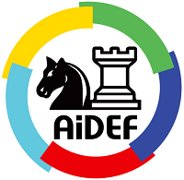
President of AIDEF

+33 6 24 97 11 24

www.aidef.fide.com

a.i.d.e.f@aol.fr

vanhoolandt@aol.com

